Computer Network Lab Task 12
Name: Mahad Ashraf
Roll No: 20P-0563
Instructor: Hurmat Hidayat
Section: BSCS(5B)
The topology of our whole process is attached below.
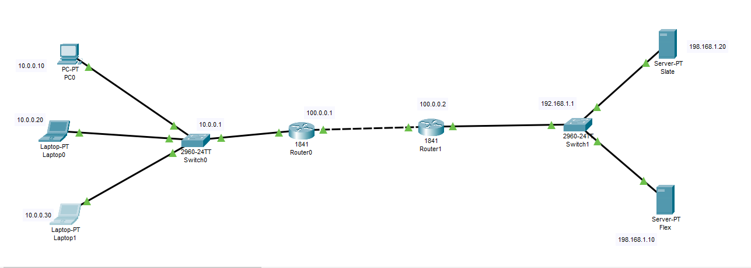.

The IP Configuration of our PC’s is mentioned below:
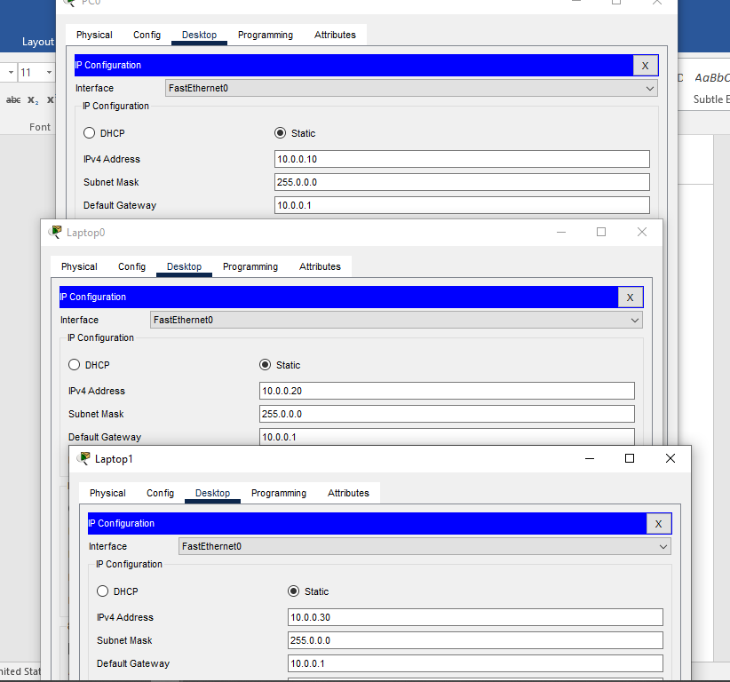.
The IP Configuration of our servers is attached below:

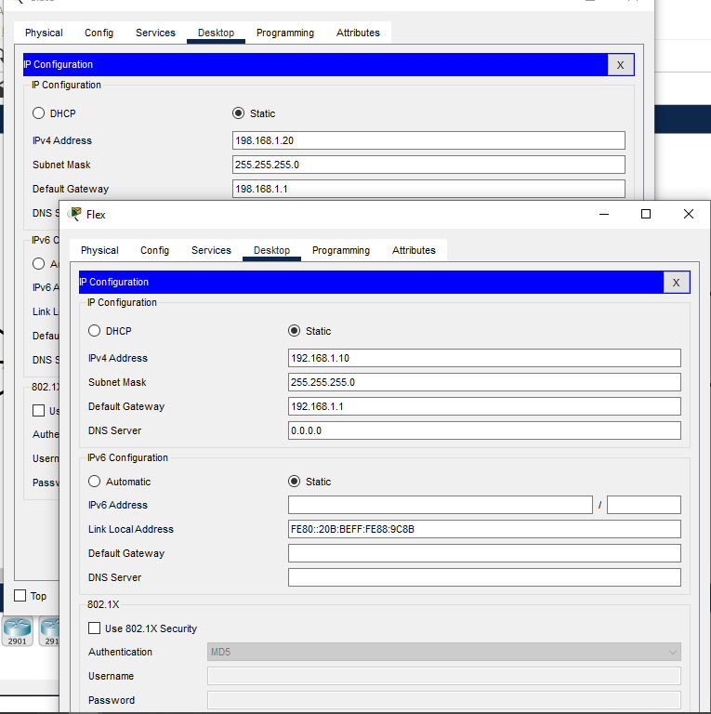.

IOS Command Line Configuration for both of the Routers is attached in the below picture.
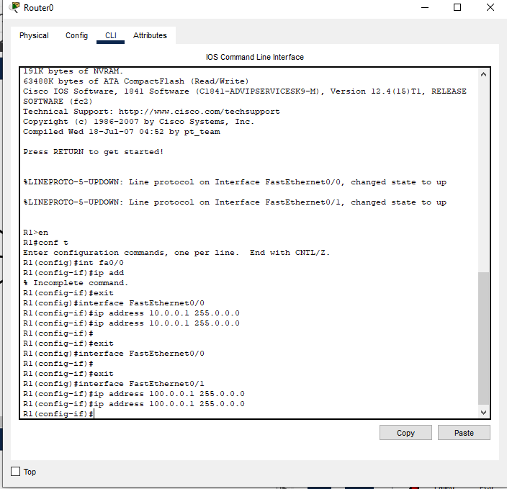
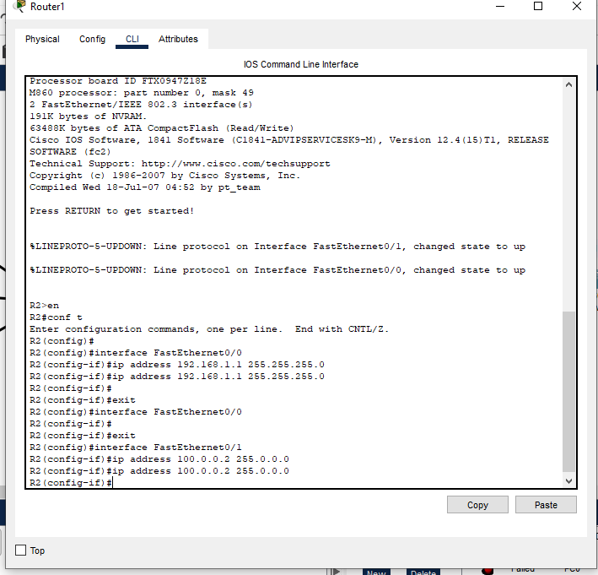

Configure Static NAT:
Here we are doing R1 Static NAT Configuration for the router 1.
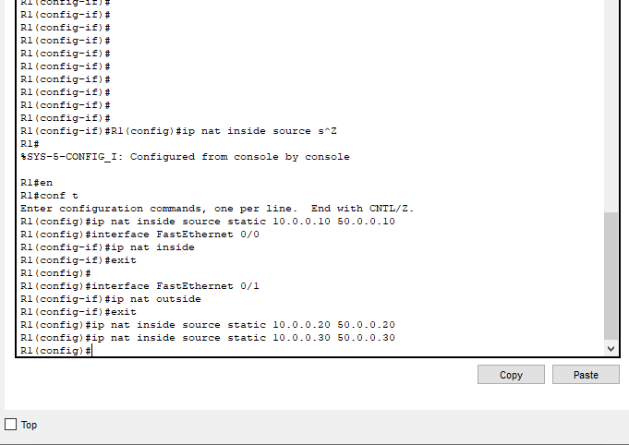

R2 Static NAT Configuration:
The Static Nat Configuration for router 2 is mentioned in the below picture.

To test this setup click Laptop0 and Desktop and click Command Prompt.
• Run ipconfig command.
• Run ping 200.0.0.10 command.
• Run ping 192.168.1.10 command.
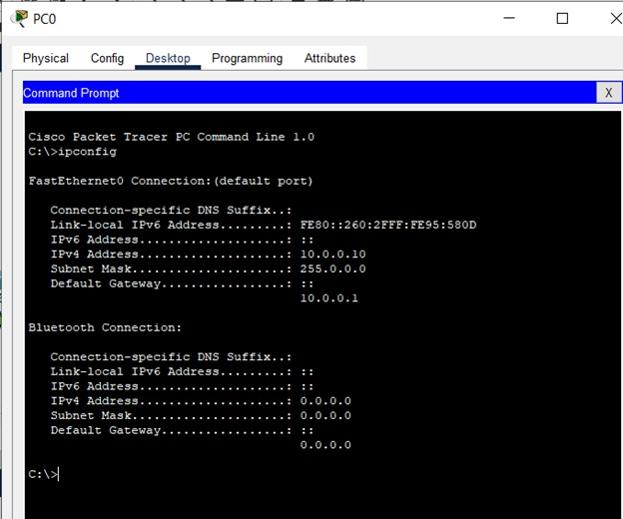
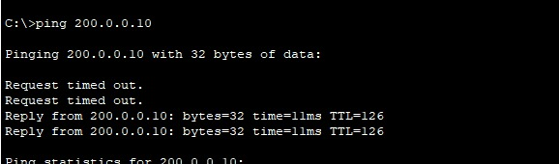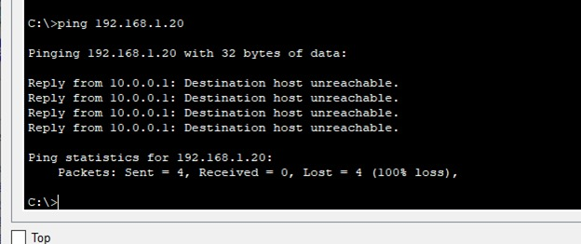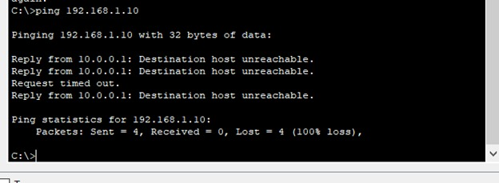Here we can see that we’ve successfully received the response of the ping test that we have performed between the PC’s. This is showing the correctness of our topology.

